Phonics
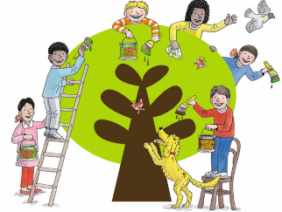
This week in phonics we have been revising the following sounds: /igh/ /oa/
Complete the following activities to practise our learning.
- Practise reading these sentences.
- Underline the correct phonics sound.
- Write the sentence out neatly.
- Draw a picture to match the sentence.

/igh/  -igh  i  -y | The bright lightening made a big flash and Chip began to cry.  It was kind of you to try to find my peach scarf.
/igh/  -ie  i-e | The zebra had black and white zigzag stripes and a tail to swat away the flies.  Wilma took four big strides and cried, “This is where we dig!”
/oa/  oa  ow  o | We called to Chip as he floated on the foaming see in his tiny boat.  Shall we throw a paper plane out of the window and see where it goes?
/oa/  -oe  o-e  -ough  -eau | I fell over the rope and even though I had shoes on, it hurt my little toe.  Wilma made the dough for her bread and spread cream on the gateau.

