Phonics
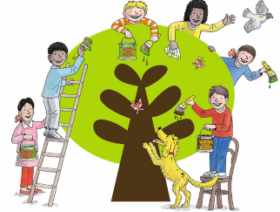
This week in phonics we have been revising the following sounds in phonics /s/ /e/
Complete the following activities to practise our learning.
- Practise reading these sentences.
- Underline the correct phonics sound.
- Write the sentence out neatly.
- Draw a picture to match the sentence.

/s/  s  -ss  -se  -ce | The postman came over to the house with two letters from the prince!  As the sunshine slid away over the hill we looked at the sunset and smiled. It was bliss here.
/s/  ce  ci  cy | I like to ride my bicycle in the city in the summer.  We went to the circus and saw a man cycle on a tightrope – he had great balance!
/s/  sc  -st- | The thistles nestle in the meadow at the foot of the castle.  Chip scrambles across the garden snipping specimens with his scissors.
/e/  e  -ea | Can we spend all the money on bread, and spread it with lots of honey?  The little bord spreads its feathers and makes an excellent first flight.

