Phonics
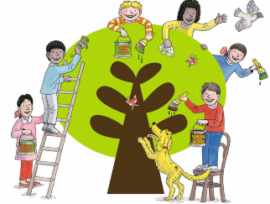
This week in phonics we have been revising the following sounds in phonics /j/ /ul/
Complete the following activities to practise our learning.
- Practise reading these sentences.
- Underline the correct phonics sound.
- Write the sentence out neatly.
- Draw a picture to match the sentence.

/j/  j  ge  gi  gy | I jumped up to see five gigantic gerbils at the pet shop.  I spent all my energy doing gymnastics and jumping!
/j/  -ge  -dge | The tiny snowy village had a slope that we liked to sledge down.  I shall arrange for six sponges to be given to Wilf for his science project.
/ul/  -le  -el | I like to travel on a camel in the desert with my father and my uncle.  I filled my bottle with liquid as I had a long way to travel.
/e/  -al  -il | At the final whistle the points were equal.  I found an animal fossil which had horizontal and vertical stripes.

